|  |  |  |  |
| --- | --- | --- | --- |
| 2 | | 23,599.285714285714 | |
| NUMERO DE FRONTERAS | | ENERGIA AGREGADA | |
|  | | | |
| NO | | 0 | |
| CONTRATO | | VENCIMIENTO CONTRATO | |
|  | | | |
| 6,303,466 | 13 | | 238,525 |
| INGRESO 2019 | DÍAS CERTIFICADOS 2019 | | ENERGIA RESPALDADA 2019 |
|  | | | |
| 86,637,866 | 209 | | 3,061,637 |
| INGRESO 2020 | DÍAS CERTIFICADOS 2020 | | ENERGIA RESPALDADA 2020 |
|  | | | |
| 41,907,770 | 111 | | 1,829,346 |
| INGRESO 2021 | DÍAS CERTIFICADOS 2021 | | ENERGIA RESPALDADA 2021 |

|  |
| --- |
| **CC BUENAVISTA**  USUARIO |

|  |
| --- |
| **Edwin Torres**  Ejecutivo de cuenta |

|  |
| --- |
| **Ricardo Insignares / Gerente / gerencia@ccbuenavista.com**  Primera fecha: PUNTO FOCAL |

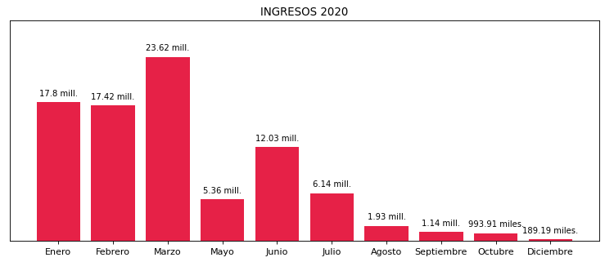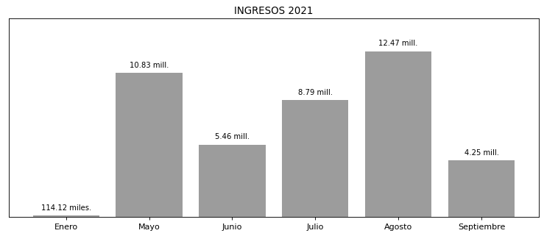

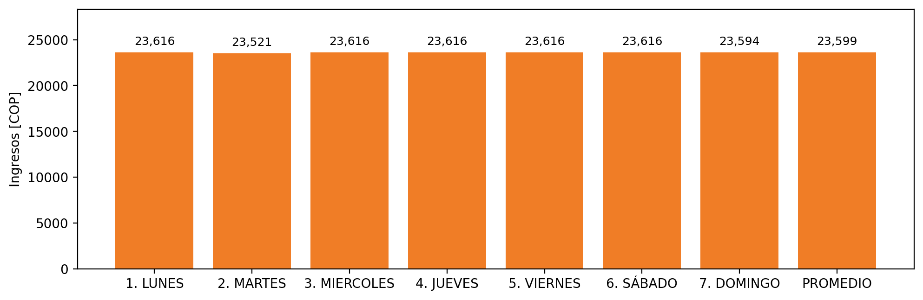

|  |  |  |  |  |  |  |  |  |  |
| --- | --- | --- | --- | --- | --- | --- | --- | --- | --- |
| **FRONTERA COMERCIAL** | **TIPO DDV** | **COD SIC** | **PREDIO** | **PROMEDIO** | **MARGEN** | **ÚLTIMA DESCONEXION** | **DÍAS CERTIFICADOS** | **ACTUALIZACION** | **PROXIMA PRUEBA DDV** |
| CENTRO COMERCIAL BUENAVISTA AREA COMUN | Frt35787 | Frt08130 | Prd01509 | 14,863 | 3,14 | 2021-10-20 | 0.0 | 2022-01-20 | 2022-02-21 |
| CENTRO COMERCIAL BUENAVISTA | Frt35146 | Frt03830 | Prd01488 | 14,863 | 2,66 | 2021-10-07 | 0.0 | 2022-03-02 | 2022-02-12 |